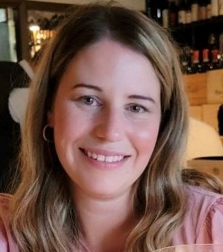
I offer practical, human-centered workshops focused on accessibility, disability awareness, and inclusive workplace practices.
Each session is designed to be engaging, relevant, and adaptable to your organization’s unique context.

Session & Workshop Topics

Disability Awareness & Inclusion
Build understanding around visible and invisible
disabilities and foster a more inclusive culture.

Workplace Accommodations
Approach accommodations with clarity, empathy, and confidence.

Navigating Sensitive Conversations
Gain tools to handle complex or uncomfortable
discussions with professionalism and care.

Inclusive Communication & Psychological
Safety
Create environments where individuals feel safe, heard, and respected.

Delivery & Format
Virtual / In-person / Hybrid
Interactive, discussion-based, lunch and learn, etc.
Suitable for leaders, teams, mixed audiences, etc.
Sessions can be customized or co-created

Tonia Gallo
Accessibility & Inclusion Facilitator

 | Montreal, QC. Canada
 | 514-246-6422
 | Toniagallo88@gmail.com

