The cycle of desire and insecurity
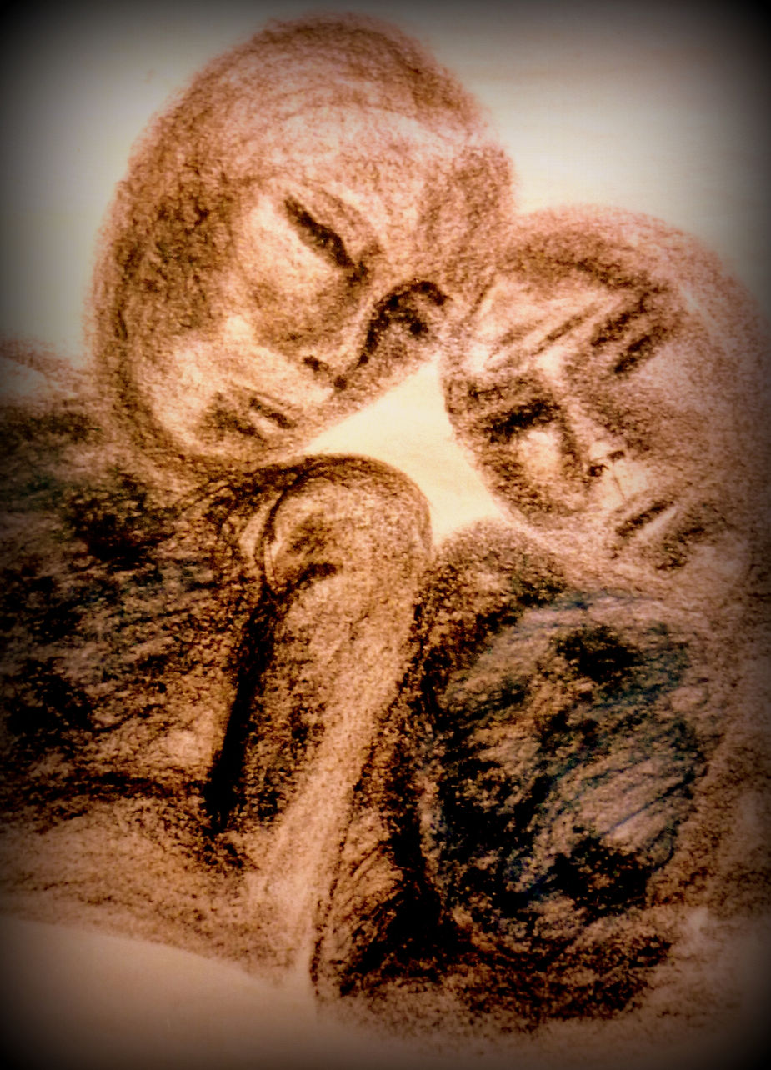

The cycle of desire and insecurity- In modern life, love often becomes a quest to be desired by others. As old social structures fade, people find themselves in a constant loop of proving their worth through appearance, achievements, and possessions. This endless chase for desirability, what Yann Dall’Aglio calls “seduction capital,” shapes not only our relationships but also our consumer habits. The more we attempt to enhance our image, the more anxious and insecure we become — trapped in a cycle where love and self-worth feel dependent on external approval.
The danger of chasing approval-Society today pushes individuals to measure their value in numbers: likes, followers, beauty standards, and financial success. These metrics create pressure to conform and fuel comparison. The relentless pursuit of admiration can make people feel disconnected, empty, and isolated. Jung points out that this loss of connection to the authentic self is at the root of much of our suffering. In trying to impress others, we risk losing who we really are, leading to frustration and emotional exhaustion.
Two ways out: tenderness and individuation- Both Yann and Jung propose different ways to break free from this trap. Yann encourages tenderness: accepting imperfection, embracing humor, and building relationships based on honesty rather than pretense. Jung offers individuation: a path of turning inward, discovering your unique qualities, and living according to your inner truth rather than society’s expectations. While tenderness focuses on connection with others, individuation strengthens the relationship with yourself, which naturally leads to more authentic connections.
Becoming whole and contributing to a healthier world- Ultimately, stepping off the treadmill of desirability allows us to reclaim our individuality and inner peace. Whether through tenderness or individuation, the result is the same: less anxiety, more acceptance, and deeper relationships. When individuals stop projecting insecurities onto others, they foster a world with more tolerance, authenticity, and kindness. By becoming whole, we don’t just heal ourselves — we contribute to a healthier, more compassionate society.

