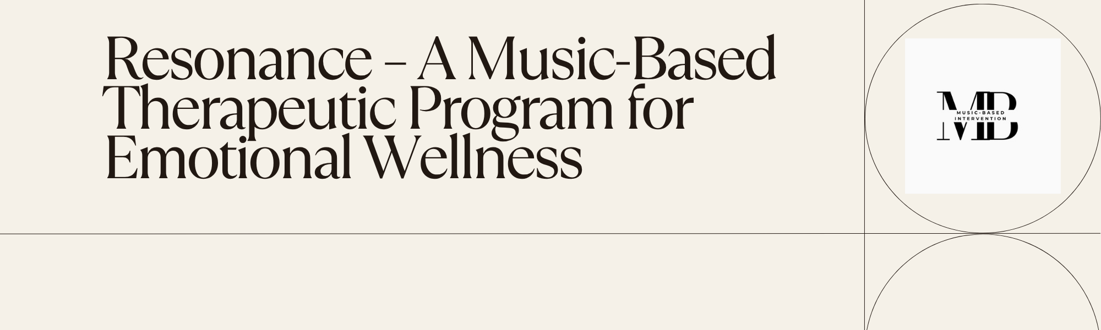
Framework for Program Structure & Delivery
Program Philosophy | Resonance is founded on the belief that music is a bridge between mind, body, and emotion. By weaving together music medicine, Cognitive Behavioural Therapy (CBT), and mindfulness practices, the program creates a nurturing space for emotional healing and self-discovery.
Therapeutic Techniques Used | CBT Tools: Thought reframing, emotion labeling, values clarification  Mindfulness Practices: Body scans, mindful breathing, acceptance exercises  Music Medicine: Specific tempos, frequencies, and singing techniques shown to promote relaxation and emotional release  Vocal Techniques: Humming, toning, vowel chanting, rhythm-based breathing
Key Principles | Non-Performance Focused – No musical skill required; focus is on inner experience  Emotional Safety First – Trauma-sensitive language and practices  Integration Over Information – Emphasis on experiential learning, not theoretical teaching  Self-Paced Sharing – No obligation to verbally share or disclose personal details
Program Outcomes | By the end of the program, participants typically experience:  - Greater emotional self-awareness and vocabulary  - Improved mood regulation and reduced anxiety  - Enhanced connection with their inner voice and intuition  - Tools for ongoing stress relief and reflection through music

EQ Growth Themes Progression:
Self-Soothing & Emotional Safety
Emotional Awareness & Naming Feelings
Emotional Release & Letting Go
Authenticity & Self-Expression
Empathy & Emotional Connection
Resilience & Inner Strength
Emotional Flexibility & Adaptability
Emotional Integration & Growth Celebration

Core Component
Component | Description | Therapeutic Aim
Guided Musical Journeys | Therapeutic singing, soundscapes, and rhythm practices curated to evoke, process, and regulate emotions | Emotional exploration, nervous system regulation
Emotional Insight & Regulation | Music-based reflection techniques and structured exercises for identifying, expressing, and managing emotions | Emotional awareness, resilience, and expression
Group Resonance Circles | Safe, supportive group spaces to experience empathy, shared emotion, and collective presence—without performance pressure | Social connection, belonging, and shared healing
Vocal Mindfulness & Breathwork | Breath-led vocal techniques to calm the nervous system and foster embodied self-awareness | Stress reduction, body-mind connection
Creative Integration | Journaling, lyric reflections, and creative activities to internalize and apply session insights | Anchoring transformation, self-expression
Program Flow
Focus
Breathwork & Vocal Mindfulness Warm-Up
Therapeutic Singing / Soundscape Immersion
Music-Facilitated Emotional Processing Techniques
Sharing Circle (Optional Verbal Sharing)
Reflective Journaling or Lyric Exercise
Closing Breathwork or Affirmation Practice

