Wednesday 24th September 2025, 6-8pm

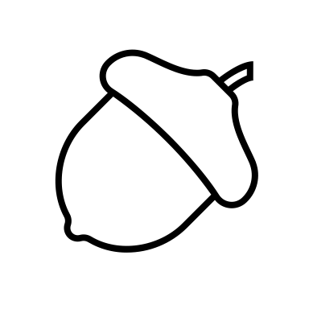 Autumn Awakening
Release the heat of summer, ground your energy and get creative
Mini-retreat for the heart, mind, body and soul

-Discuss and harness the energy of the season
-Set an intention for your practice
-Carry out a centring Yoga sequence
-Enjoy an ayurvedic warm oil foot self-massage
-Explore physical theatre approaches inspired by animal characters - experimenting with both independent and collaborative movement
-Refresh with turmeric and ginger herbal teas
-Connect with like-minded people

*Ayurveda is an ancient healing system originating in India over 4,000 years ago. Ayurvedic approaches include: use of herbs, massage, diet and lifestyle changes. Ayurveda is a sister science of Yoga.

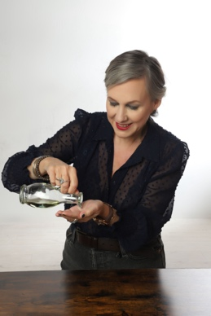

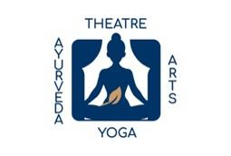
Take time and space to: breath out, release, restore and tune into your imagination. All levels welcome.

Led by Caroline Jeyaratnam-Joyner at: https://www.greenwichpilates.co.uk/

We will use Grapeseed Oil. Please get in touch if you have any allergies.
Please also let me know if you have any injuries or ailments, so I can tailor the workshop.

Booking in advance is essential. Please email caroline@jeyaratnam-joyner.com to book via bank transfer.

And look out for mini-retreat Winter Warming
-17th December, 6-8pm - at Greenwich Pilates

Tailored one-to-one programmes also available

