Facilitator Application – Culture Vitale Sessions of Vitality

Dear Culture Vitale team,
I was delighted to come across your call for facilitators — your idea of “Sessions of Vitality” feels wonderfully alive and aligned with what I love doing most: creating moments where people can slow down, reconnect, and rediscover their spark.
I’m a coach and trainer based in Brussels, with over 15 years of experience bringing well-being, resilience, and creativity into organisations — from the European Commission, Parliament, and NATO to companies like IKEA, Facebook, and Amazon. My work blends neuroscience, mindfulness, and embodied awareness to help people move from stress and autopilot to calm, clarity, and authentic connection.
I’d be thrilled to contribute to your sessions with short, engaging workshops such as:
- “From Stress and Struggle to Calm and Focus” – practical tools to reset the nervous system and restore balance
- “Micro Habits for Well-being” – small, sustainable actions that boost energy and emotional resilience
- “Relax and Rejuvenate” – a restorative experience using movement, breath, and awareness to release tension and recharge
I love weaving science and heart together — creating experiences that stay with people long after the session ends. It would be a joy to bring that spirit to the Culture Vitale community.
Warmly,
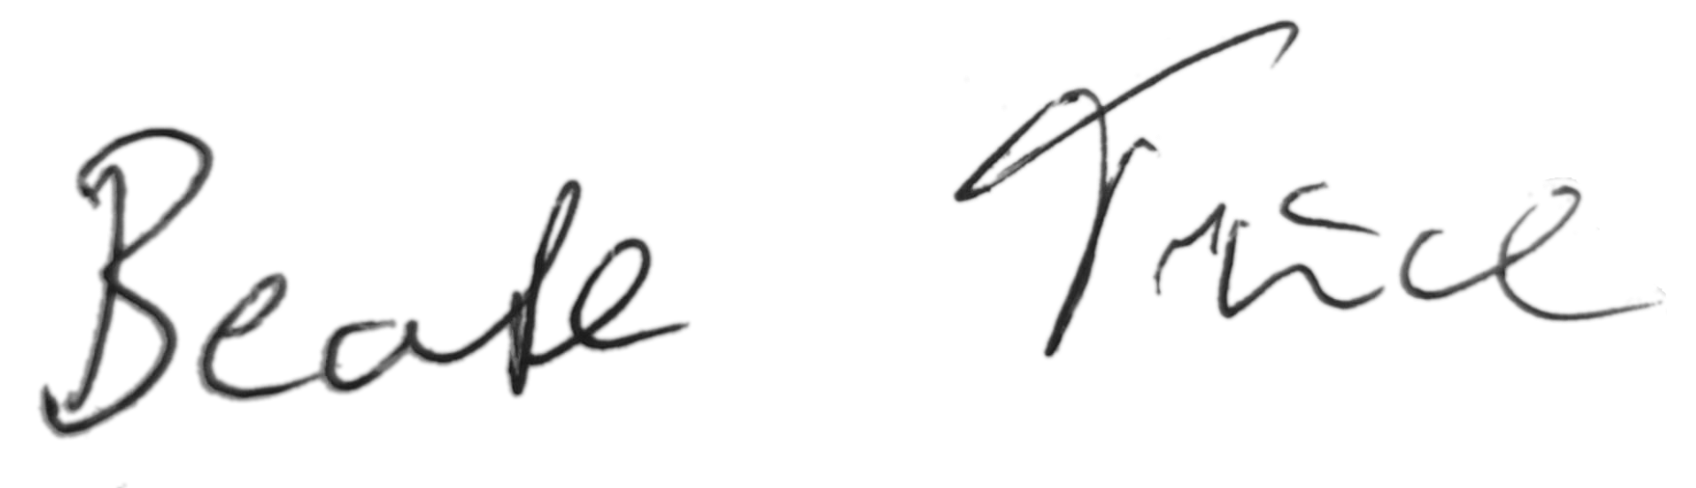
Beate Trück
Transformative Coach & Trainer | Brussels Mindfulness / Rewire & Rise
📍 Brussels, Belgium
🌐 www.brusselsmindfulness.be
✉️ beate.trueck@brusselsmindfulness.be | +32 [insert number]

