Dr. Michael Kausch

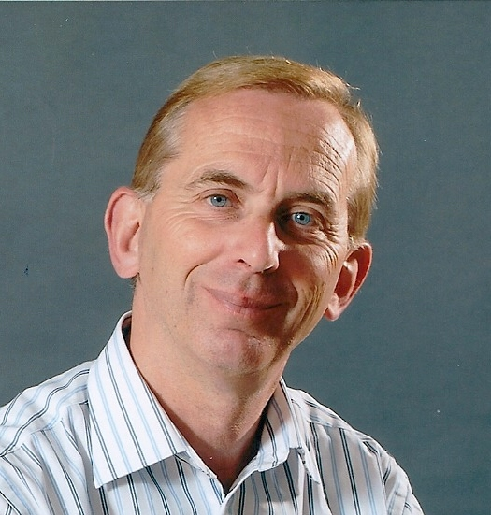

Curriculum vitae

To the Person_________________________________________________________________

Name: Michael Kausch

Address Eschenrieder Straße 11
82194 Gröbenzell

Training, coaching and consulting

2025 Advanced Training Value-Oriented Systemic Leadership Coach,
(CAS/ISO/ICI), Coach Academy Switzerland

From 2024 training in logotherapy and existential analysis according to Viktor E. Frankl

2023 Trainer/Coaching Training at the Dr. G. Kitzmann Academy

10/2023 Advanced Training Value-Oriented Systemic Health Coach,
(CAS/ISO/ICI), Coach Academy Switzerland

7/2023 Advanced Training Value-Oriented Systemic Business Coach,
(CAS/ISO/ICI), Coach Academy Switzerland

6/2023 Advanced Training Value-Oriented Systemic Constellation Coach
(CAS/ISO/ICI), Coach Academy Switzerland

3/2023 Diploma in Value-Based Coach & Consultant (CAS/ISO/ICI),
Coach Academy Switzerland

1-2/2023 Training in Talk Therapy according to Rogers, Center for
Naturopathy, Munich

2018-2021 Participation in the Business Coaching Program of Lambert Academy, Frankfurt/M.

2014-2015 Apprenticeship as a real estate agent IHK

5/2000 Participation in the seminar "Communication and Basic Skills for Executives"

Berufserfahrung_ & Business Aktivitäten___________________________________

Since 2023 work as coach and trainer

9/2014-2022 Activity as a self-employed real estate agent and appraiser

9/2008-3/2016 Representative/Consultant of the
Hapimag AG, Baar, in the area of Germany/South
(Timeshare – Vacation Properties)

Since winter semester 2007 private lecturer at the Institute for Art History of the
University of Koblenz-Landau

Since winter semester 2004/5 lecturer at the Institute of Art History of the
University of Koblenz-Landau

1996 Founding of the company Art Concept Dr. Michael Kausch
Division: Organization of exhibitions, lectures,
Conferences, conception and implementation
of study trips

1995-1998 Exhibition curator at the Kunsthistorisches Museum, Vienna

1994-2002 Lecturer at the Institute of Art History at the University
Innsbruck

1990-1995 Activity as study tour guide for Studiosus Reisen, Munich

Scientific Ausbildung_________________________________________________

Habilitation 2007 Granting of the venia legendi for the entire subject
Art History at the University of Koblenz – Landau

2005 Bachelor's Degree in Philosophy
College for 1999-2005 Study of Philosophy
Philosophy
Philos. Faculty S.J.,
Munich

Promotion 1993 Doctorate in Philosophy with Distinction

Graduated 1989 Graduated with a Master's degree in Philosophy Distinction

University
Innsbruck/ 1983 - 1994 Studies of Art History, German Studies and
Philosophy

LMU Munich

University 1976 - 1983 Study of Medicine
Innsbruck

General Kenntnisse_______________________________________________________

Foreign languages: English, French, Italian (all fluent)

EDP Office, Database Systems, CRM Systems, Digital Image Processing,
AI applications etc.

