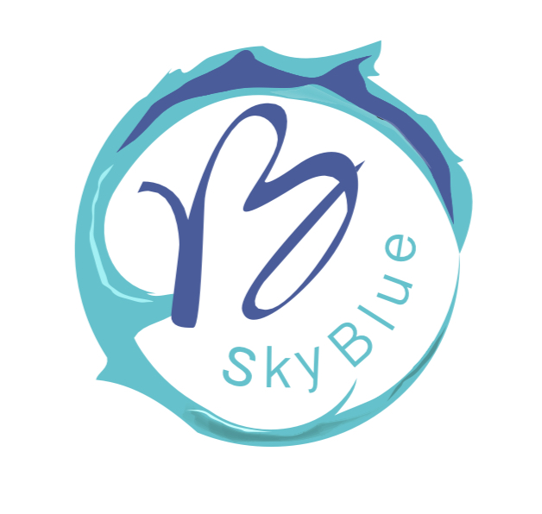

Workshop Proposal for Culture Vitale

Title:
Creative Wall Design for Team Empowerment

Duration:
Three sessions – each 3 hours. Workshops vary depending on the technique and can range from a single session to several sessions, tailored to the method and approach being used. This flexibility allows the programme to be adapted to the needs of each group.

Overview
This workshop is a unique, hands-on experience that takes participants out of their daily routine and immerses them in an inspiring creative process. Through the practice of Wall Design, participants will have the opportunity to create artworks both individually and collectively. This dual approach enables individuals to explore personal creativity and self-expression, whilst also strengthening collaboration, empathy, and teamwork. By the end of the programme, a collective artwork will be completed as a symbol of shared team values and identity, whilst individual pieces may also be kept as personal achievements.

Session Structure
Session 1 – Discovering Individual Creativity
• Introduction to Wall Design and the role of art in personal and professional growth
• Creative warm-up exercises to boost confidence and expression
• Individual artwork creation (each participant produces a small personal piece)
• Group reflection and discussion
Session 2 – Building Together: Texture, Design & Base Colours
• Preparing panels and applying textures
• Collaborative and individual design development
• Applying base colours and shaping the initial design
• Sharing ideas and merging creative directions in the group artwork
Session 3 – Bringing It to Life: Final Colours & Finishing Touches
• Completing both individual and group artworks with final colours and details
• Applying primers and finishing techniques for a professional result
• Assembly and presentation of the collective piece
• Final reflection and discussion on the creative journey and its connection to teamwork

Outcomes
• A collective wall artwork ready to be installed or displayed in the workplace
• Individual artworks participants may keep as personal mementoes
• Increased confidence, creativity, empathy, and collaboration skills
• An inspiring and memorable experience with both individual and group dimensions

Requirements
• A spacious room suitable for group activity
• Tables or working surfaces for participants
• Art materials (provided by the facilitator or arranged with the company)

About the Facilitator
With 24 years of experience in teaching art and managing an art school, and extensive knowledge of diverse artistic styles and techniques, I bring both expertise and passion to every workshop I lead. This background enables me to adapt sessions to the unique needs of each group, creating a supportive, inspiring, and empowering atmosphere for all participants.
I have delivered similar workshops at Middlesex University, both for students and for participants from outside the university. In addition, I have led art workshops at Barnet Mencap (for autistic adults), where I continue to work. I have also curated and organised several exhibitions of my students’ artworks at Middlesex University.

Closing Note
I would be happy to share with you a YouTube video link showcasing one of my projects completed last year, so you can see a sample of my work in action.
Thank you very much for your time and consideration. I look forward to the possibility of collaborating with Culture Vitale and contributing to your creative community.
Warm regards,
Vida Baradarannia

